A000-AM,C-Taino-Tripointer-Anthropomorphic Face-Serpentine motif-1000 CE

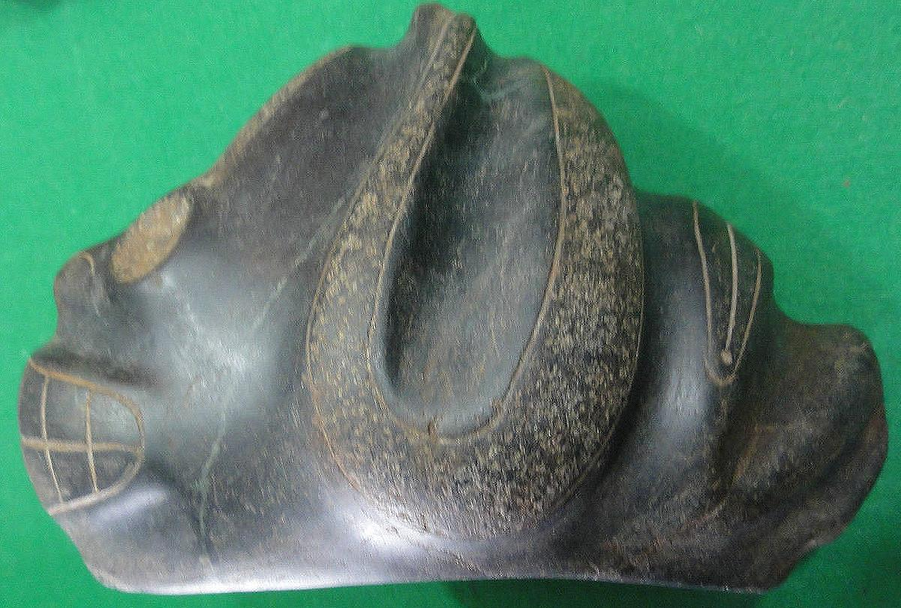

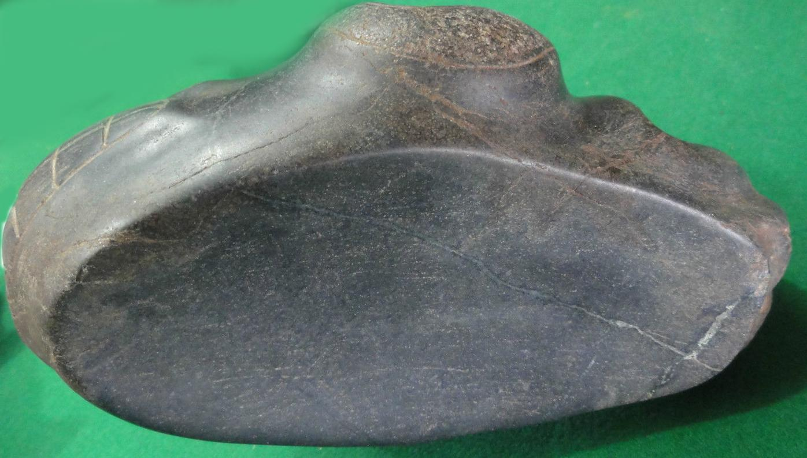

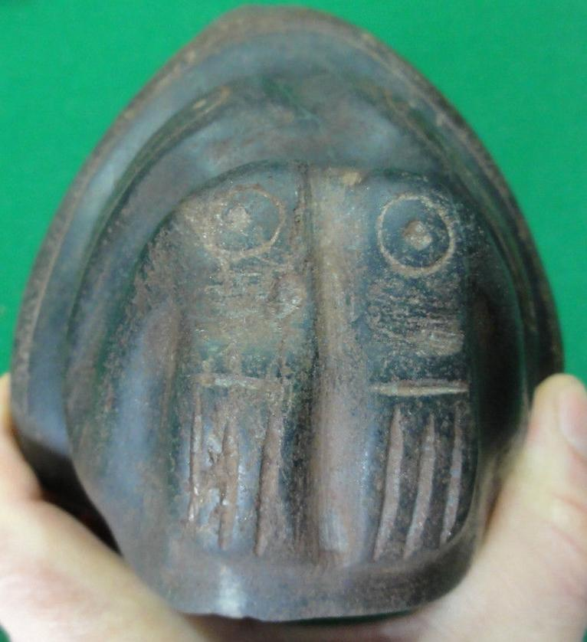 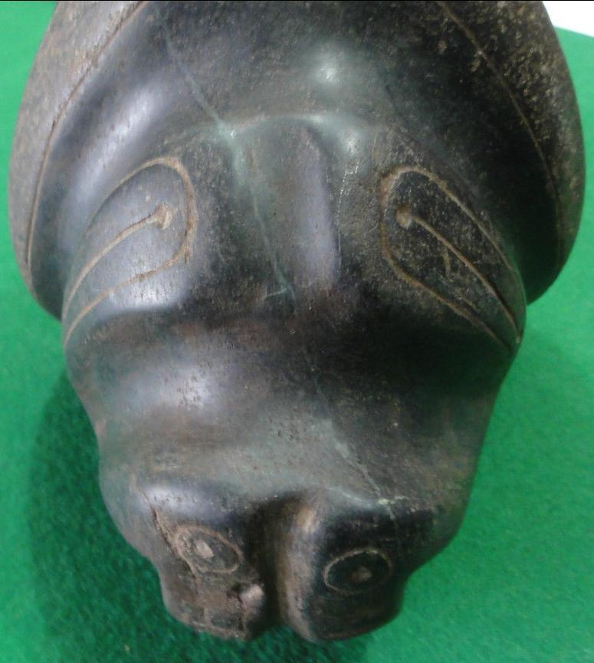 z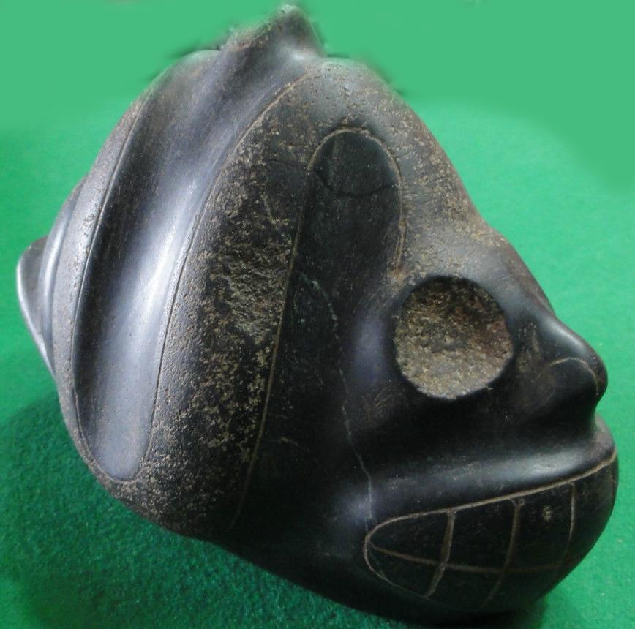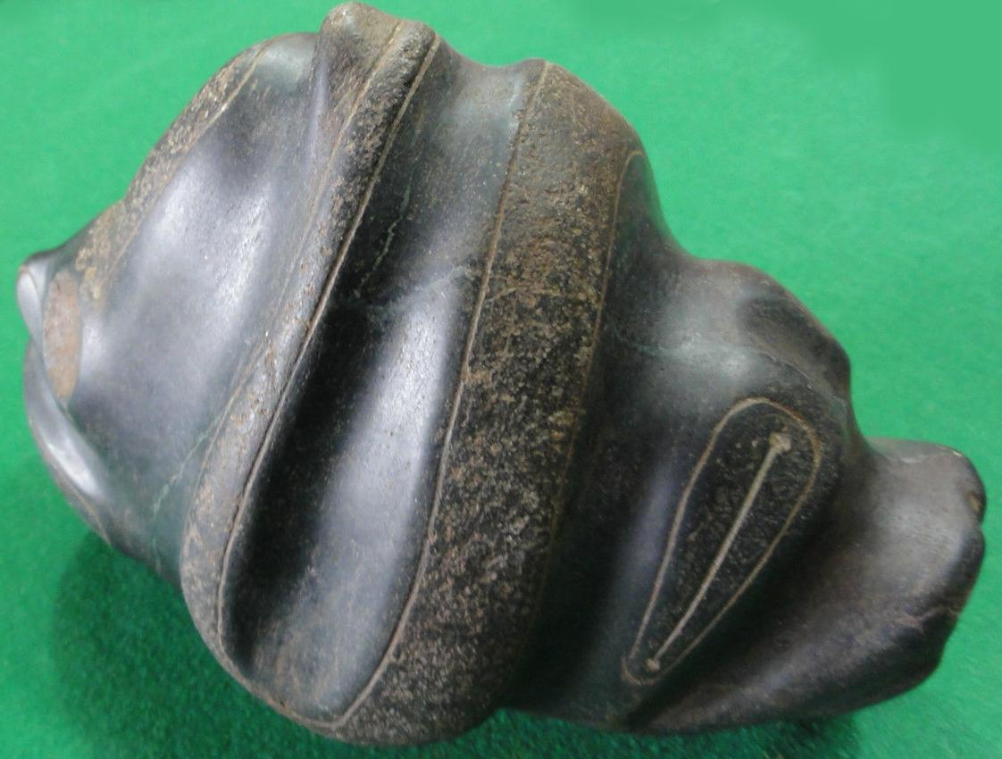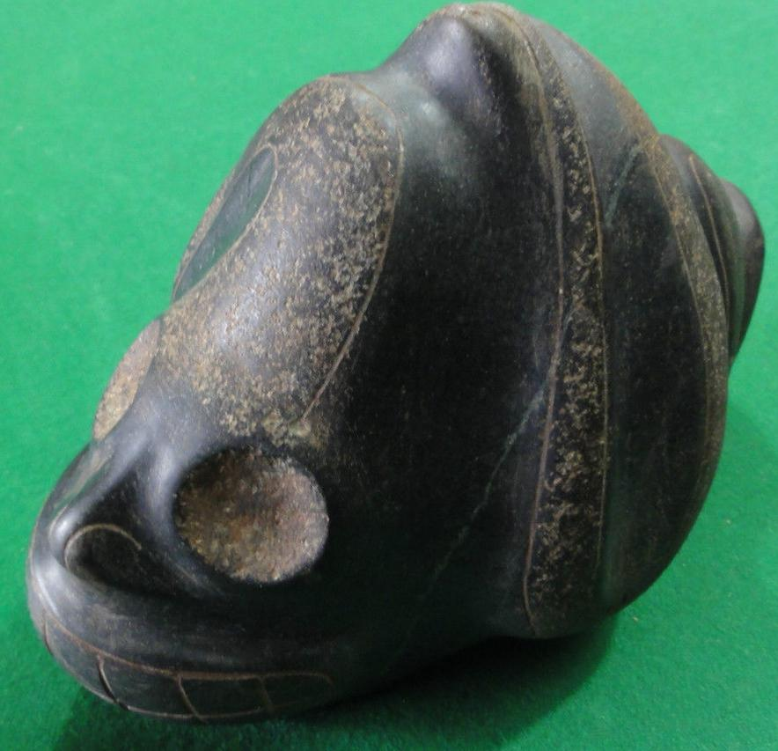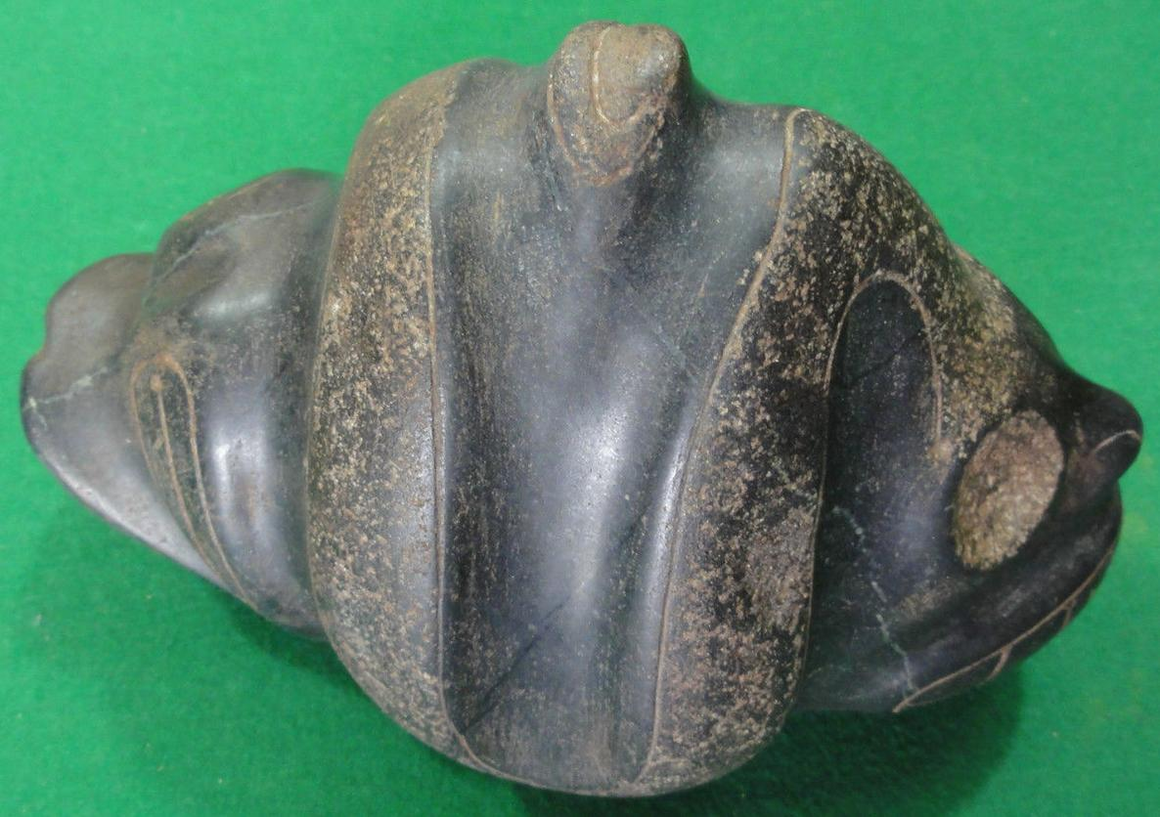

Figs. 1-8. AM,C-Taino-Tripointer-Anthropomorphic Face-Serpentine motif-1000 CE

Case No.: 17

**Accession No.**

**Formal Label:** AM,C-Taino-Tripointer-Anthropomorphic Face-Serpentine motif-1000 CE

**Display Description:**

Very rare dual curvilinear serpentine motif which encompasses an anthropomorphic figure. The only published example that I have been able to find uses the same curvilinear serpentine motif is in the Museo Arqueologico Regional, Altos de Chavon, Dominican Republic (Bercht, Brodsky, Farmer and Taylor 1997, cat. No. 77, 78).

**LC Classification:**

**Date or Time Horizon: 1000 CE**

**Geographical Area:**

**Map:**

**GPS coordinates:**

**Cultural Affiliation:**

**Media:**

**Dimensions:**

**Weight:**

**Condition:**

**Provenance:**

**Discussion:**

**References:**

Alegría, Ricardo E; José Juan Arrom; Dicey Taylor; Fatima Bercht; Estrellita Brodsky; Museo del Barrio. 1998. Taíno: pre-Columbian art & culture from the Caribbean, September 27, 1997-March 29, 1998, El Museo del Barrio, New York City = artes y cultura precolombinas del Caribe, 27 de septiembre de 1997 a 27 de marzo 1998. NY: New York.